St Joseph School Pizza Order Form

2022-2023

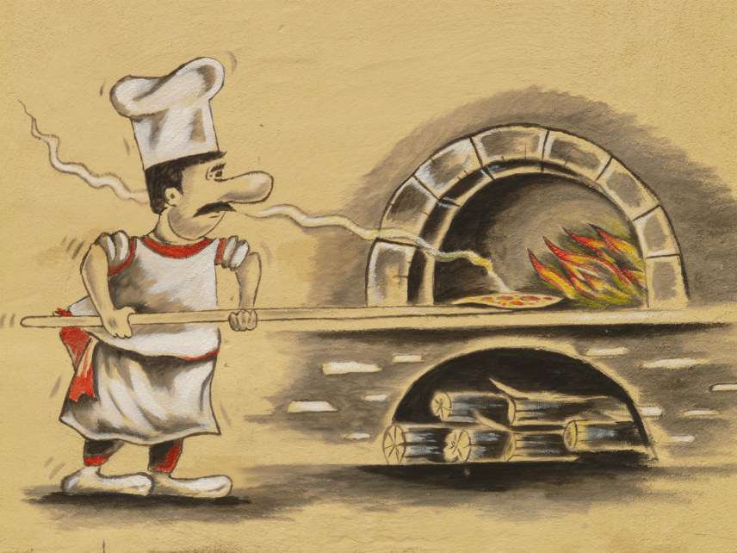

Parents who wish to purchase pizza for their children, there will be one pizza payment for the 2022-2023 school year. Pizza distribution will begin, Friday, September 23, 2022.

1 slice $ 35.00 per child/year

2 slices $ 70.00 per child/year

3 slices $105.00 per child/year

Family Name: __________________________________________

Email Contact: __________________________________________

Child 1: ____________________ Grade ________ # of slices _________ Total: $ _____________

Child 2: ____________________ Grade ________ # of slices _________ Total: $ _____________

Child 3: ____________________ Grade ________ # of slices _________ Total: $ _____________

Child 4: ____________________ Grade ________ # of slices _________ Total: $ _____________

Grand Total: $ _____________

Payment:

_____ Check made payable to Saint Joseph School

_____ FACTS Management

***Please complete and return this form to the front desk by **Friday, September 16, 2022**\*\*\*

For any questions, please email: Assunta C. Eramo at [Sue2621@yahoo.com](mailto:Sue2621@yahoo.com)